TOPIC performance of graph autoencoders for link prediction on social network(ego network) and statistical analysis .

**TRAINING OUTPUT**

Total nodes: 2247

Total edges: 81832

Training edges (positive): 49100

Training edges (negative): 49100

Validation edges (positive): 8183

Validation edges (negative): 8183

Test edges (positive): 24549

Test edges (negative): 24549

Creating GAE optimizer...

Labels shape: (?,)

Preds shape: (5049009,)

CE+KL loss shape: ()

Epoch: 0001 train_loss= 1.42046 train_acc= 0.50026 val_roc= 0.87720 val_ap= 0.87428 time= 2.81500

Epoch: 0002 train_loss= 1.36602 train_acc= 0.50002 val_roc= 0.87905 val_ap= 0.87719 time= 1.41000

Epoch: 0003 train_loss= 1.34949 train_acc= 0.49810 val_roc= 0.87870 val_ap= 0.87704 time= 1.41701

Epoch: 0004 train_loss= 1.29404 train_acc= 0.49828 val_roc= 0.87840 val_ap= 0.87683 time= 1.47005

Epoch: 0005 train_loss= 1.25881 train_acc= 0.49548 val_roc= 0.87823 val_ap= 0.87668 time= 1.36697

Epoch: 0006 train_loss= 1.21735 train_acc= 0.49118 val_roc= 0.87813 val_ap= 0.87662 time= 1.37498

Epoch: 0007 train_loss= 1.18899 train_acc= 0.48946 val_roc= 0.87808 val_ap= 0.87659 time= 1.38398

Epoch: 0008 train_loss= 1.12896 train_acc= 0.48601 val_roc= 0.87803 val_ap= 0.87653 time= 1.39599

Epoch: 0009 train_loss= 1.09078 train_acc= 0.47963 val_roc= 0.87800 val_ap= 0.87650 time= 1.37197

Epoch: 0010 train_loss= 1.03087 train_acc= 0.47836 val_roc= 0.87798 val_ap= 0.87649 time= 1.40800

Optimization Finished!

Test ROC score: 0.873162970004

Test AP score: 0.871685250406

NETWORK GRAPH

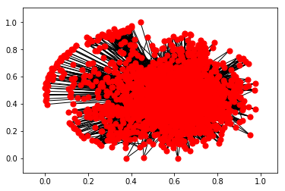

**PROBABILITY DISTRIBUTION USING POISSONS**

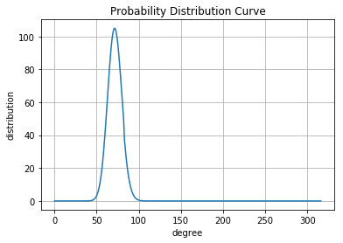

**LOG LOG GRAPH**

